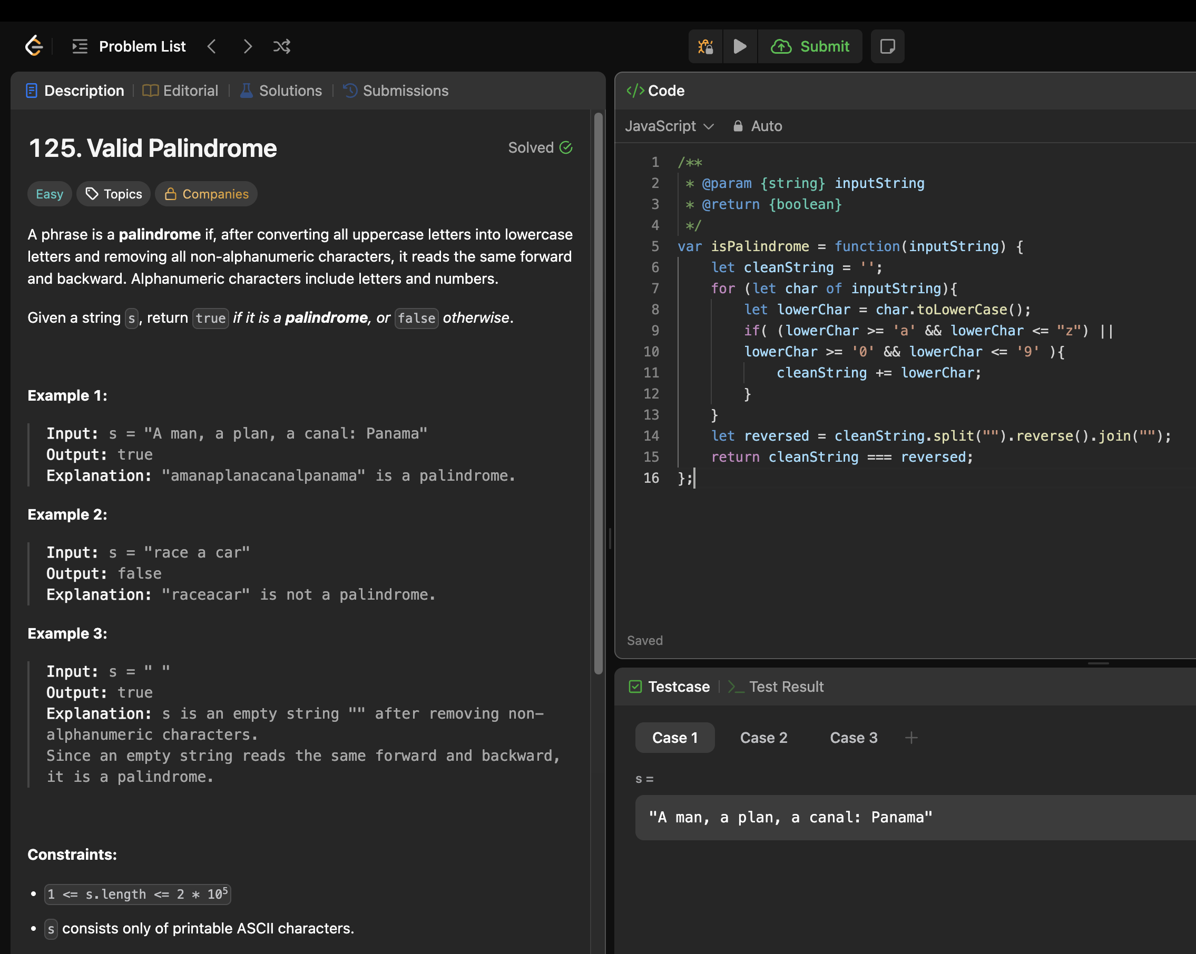

1. This is very straight forward.

We are checking the string with abcdefghijklmnopqrstuvwxyz0123456789

And then checking if the reverse matches the initial one.